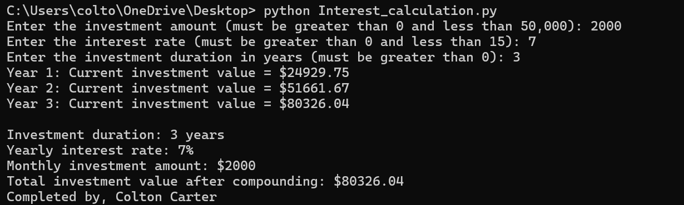

investment_amount = int(input("Enter the investment amount (must be greater than 0 and less than 50,000): "))

while investment_amount <= 0 or investment_amount >= 50000:

print("Invalid amount. Please enter a value greater than 0 and less than 50,000.")

investment_amount = int(input("Enter the investment amount (must be greater than 0 and less than 50,000): "))

interest_rate = int(input("Enter the interest rate (must be greater than 0 and less than 15): "))

while interest_rate <= 0 or interest_rate >= 15:

print("Invalid rate. Please enter a value greater than 0 and less than 15.")

interest_rate = int(input("Enter the interest rate (must be greater than 0 and less than 15): "))

investment_duration_years = int(input("Enter the investment duration in years (must be greater than 0): "))

while investment_duration_years <= 0:

print("Invalid duration. Please enter a value greater than 0.")

investment_duration_years = int(input("Enter the investment duration in years (must be greater than 0): "))

investment_duration_months = investment_duration_years * 12

monthly_interest_rate = (interest_rate / 12) / 100

total_investment = 0

for month in range(1, investment_duration_months + 1):

total_investment += investment_amount

interest = total_investment * monthly_interest_rate

total_investment += interest

total_investment = round(total_investment, 2)

if month % 12 == 0:

print(f"Year {month // 12}: Current investment value = ${total_investment}")

print(f"\nInvestment duration: {investment_duration_years} years")

print(f"Yearly interest rate: {interest_rate}%")

print(f"Monthly investment amount: ${investment_amount}")

print(f"Total investment value after compounding: ${round(total_investment, 2)}")

print("Completed by, Colton Carter")